A Minor Project Report

on

**IOT Based Weather Monitoring System**

*carried out as part of the course (CC1653) Submitted by*

Akash Adhikari(159101013)

Arjit Yadav(159101032)

VI Semester, B.TECH, CSE-A

In partial fulfillment for the award of the degree

of

**BACHELORS OF TECHNOLOGY**

**in**

In Computers Science and Engineering

2015-2019



Under the guidance of

Ms. Anubha Parashar

**Department of Computer Science and Engineering**

**School of Computing and Information Technology**

**Manipal University Jaipur**

April,2018

**Certificate**

This is to certify that the minor project titled “**IOT Based Weather Monitoring system**” is the bona fide work carried out by AKASH ADHIKARI and ARJIT YADAV, students of B Tech (CSE) of Manipal University Jaipur during the academic year 2017-18, in partial fulfillment of the requirements for the award of the degree of Bachelor of Technology (Computer Science and Engineering ) and that the project has not formed the basis for the award previously of any other degree, diploma, fellowship or any other similar title.

**Signature of the Guide**

**Place:**

**Date:**

**DECLARATION**

I hereby declare that the project entitled **“IOT Based Weather Monitoring system**” submitted as part of the partial course requirements for the Minor Project, for the award of the degree of Bachelor of Technology in Computer Science Engineering at Manipal University Jaipur during the VI semester, April 2018 , has been carried out by Akash Adhikari and Arjit Yadav. We declare that the project has not formed the basis for the award of any degree, associate ship, fellowship or any other similar titles elsewhere.

Further, I declare that I will not share, re-submit or publish the code, idea, framework and/or any publication that may arise out of this work for academic or profit purposes without obtaining the prior written consent of the Course Faculty Mentor and Course Instructor.

Signature of the Students:

Place:

Date:

**Abstract**

Weather forecasting is the application of science and technology to predict the state of the atmosphere for a given location. Human beings have attempted to predict the weather informally for millennium and formally since the nineteenth century. Weather forecasts are made by collecting quantitative data about the current state of the atmosphere on a given place and using scientific understanding of atmospheric processes to project how the atmosphere will evolve on that place.

Weather is driven by air pressure (temperature and moisture) differences between one place and another. These pressure and temperature differences can occur due to the sun angle at any particular spot, which varies by latitude from the tropics. The atmosphere is a chaotic system, so small changes to one part of the system can grow to have large effects on the system as a whole. This makes it difficult to accurately predict weather more than a few days in advance, though weather forecasters are continually working to extend this limit through the scientific study of weather, meteorology. It is theoretically impossible to make useful day-to-day predictions more than about two weeks ahead, imposing an upper limit to potential for improved prediction skill.

**Table of Contents**

1. Introduction 5

1.1. Scope of the Work 5

1.2. Product Scenarios 5

2. Requirement Analysis 6

2.1. Functional Requirements 6

2.2. Non-functional Requirements 6

2.3. Use Case Scenarios 7

3. System Design 7

3.1. Design Goals 7

3.2. System Architecture 8

3.3. Detailed Design Methodologies 9

4. Work Done 10

4.1. Development Environment. 10

4.2. Results and Discussion 10

4.3. Individual Contribution of project members 10

5. Conclusion and Future work 11

5.1. Proposed Work plan of the project 11

References Appendix 12

1. **Introduction**

**1.1. Scope of the Work**

Through weather monitoring system we can collect the information about humidity and temperature and according to current and previous data we can produce the results in graphical manner in the system. After reviewing many articles, there are presently no papers that mention monitoring the combination of temperature, lighting and humidity in one integrated system and have actuators to modify these settings. In addition to this, there is one research paper that has discussed monitoring these three environmental conditions; however, there has been no mention about having actuators to modify. So our main idea was to coin a system that can sense the main components that formulates the weather and can be able to forecast the weather without human error.

* 1. **Product Scenarios**

Based on the framework shown in figure , we have identified a suitable implementation model that consists of different sensor devices and other modules, their functionalities are shown in figure 3.In this implementation model we used Arduino UNO board with Wi-Fi module is as embedded device for sensing and storing the data in cloud. Arduino UNO board consist of analog input pins (A0-A5), digital output pins (D0-D13), inbuilt ADC and Wi-Fi module connects the embedded device to internet. Sensors are connected to Arduino UNO board for monitoring, ADC will convert the corresponding sensor reading to its digital value and from that value the corresponding environmental parameter will be evaluated.

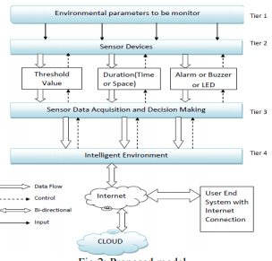

1. **Requirement Analysis**

**2.1. Functional Requirements**

The field element shall include surface and sub-surface environmental sensors that measure road surface temperature, moisture, rain as specified in the plans.

* 1. **Non-functional Requirements**

When specified in the plans, the wifi module shall remotely aggregate environmental sensor data with environmental data collected.

* 1. **Use Case Scenarios**

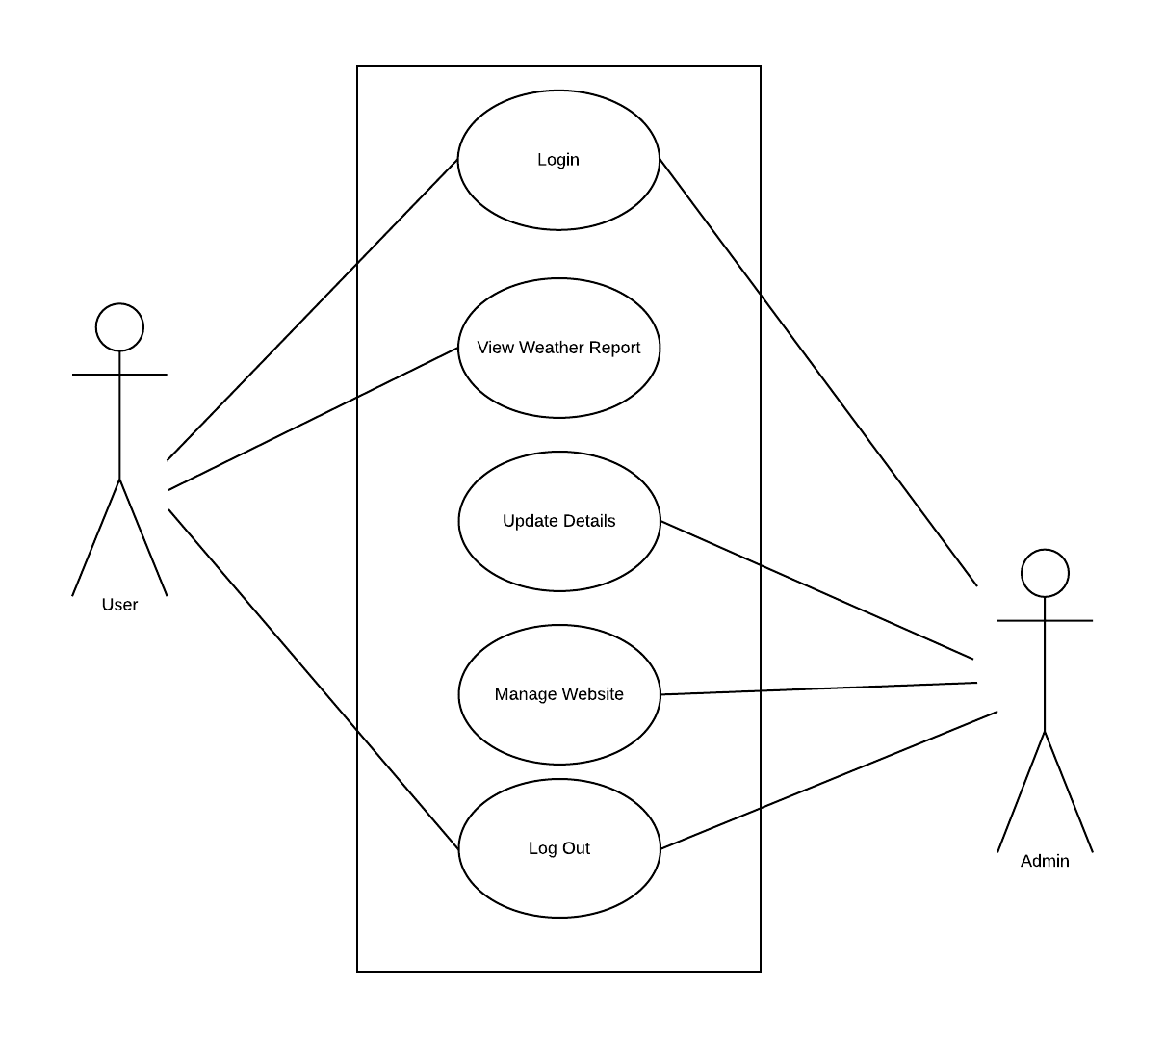

**3. System Design**

**3.1. Design Goals**

The proposed embedded device is for monitoring Temperature, Humidity, and Pressure, light intensity, sound intensity levels and CO levels in the atmosphere to make the environment intelligent or interactive with the objects through wireless communication. The proposed model is shown in figure 2 which is more adaptable and distributive in nature to monitor the environmental parameters. The proposed architecture is discussed in a 4- tier model with the functions of each individual modules developed for noise and air pollution monitoring. The proposed model consists of 4-tiers. The tier 1 is the environment, sensor devices in tier 2, sensor data acquisition and decision making in tier 3 and intelligent environment in tier 4.The proposed architecture is shown in figure 2. Here, the tier 1 provides information about the parameters under the region which is to be monitored for noise and air pollution control. Tier 2 deals with the sensor devices with suitable characteristics, features and each of these sensor devices are operated and controlled based on their sensitivity as well as the range of sensing. In between tier 2 and tier 3 necessary sensing and controlling actions will be taken depending upon the conditions, like fixing the threshold value, periodicity of sensing, messages (alarm or buzzer or LED) etc. Based on the data analysis performed in between tier 2 and tier 3 and also from previous experiences the parameter threshold values during critical situations or normal working conditions are determined. Tier 3 describes about the data acquisition from sensor devices and also includes the decision making.

**3.2. System Architecture**

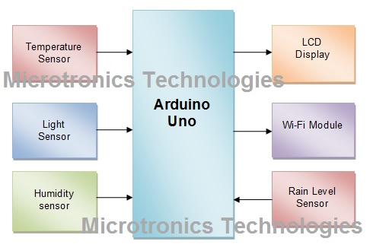

**3.3. Detailed Design Methodologies**

The working principle of this work describes the interdependent functionality of the components and their output. The circuit diagram is shown above. Firstly, all the components are initialized by supplying the required power of +5v. There are two temperature sensors, lm35 and dht11; we are using two temperature sensors to get a accurate value of temperature reading and taking the average of the two values. Depending on the temperature, hot air or cool air introduced to maintain the temperature threshold value, which is preset. If the temperature is too low for the particular area hot air is blown in to bring the temperature to moderation. Otherwise, if the temperature is too high, cold air is blown and thereby raising the temperature to the required level. This is how temperature is manipulated. Secondly, there is an LDR which work based on light intensity. When the sunlight is too much or not enough for the plant to handle, the servo motor opens or closes the door of the glass box based on the readings of the LDR. This helps in recording the natural light incident on the area. The natural light intensity may wary from time to time. This is important in agricultural applications, where light is required for the growth of plants and some plants may not grow well in low light. On the other hand, when the light intensity is high throughout the year, such areas or places are suitable to set up solar power stations. Light intensity along with other parameters such as temperature and humidity can be used in predicting weather forecast without the use of any satellite data.

The gathered data is serially fed into a computer, which uses the com port to communicate with the Arduino device and the data recorded is stored in a text file. The text file can be directly imported to an excel file with the functionality of a macro. The imported data is then sorted and formatted, and charts are then plotted with the imported data. The charts present a visual representation of the data, which shows the weather pattern over a recorded period of time. The visual patterns indicate the weather behaviour of the particular region. This is the primary objective of the present work.

The DHT11 sensor provides the current temperature are humidity readings. The DHT11 gives out analog output and is connected to the analog input of the Arduino micro-controller A0. The dht11 sensor has 3 pins. Along with temperature and humidity the other values that are calculated or derived from the dht11 sensor is the dew point, heat index etc. The dew point is the temperature at which air in the atmosphere freezes to become water droplets and the heat index is the heat felt by the human skin from the environment. This is important in places with high humidity. Even though the temperature maybe lower, the body still feels warm. This is due to the high humidity in the air. Humidity is the moisture content in the air. High humidity in the air generally makes one to sweat or perspire. The lm35 is a general purpose temperature sensor. The need of this sensor is to get an additional reading of the temperature. Along with the dht11 sensor’s temperature reading, we calculate the lm35 sensors temperature reading as well and an average of the two readings are taken to get an accurate reading of the surrounding temperature. Bmp180 sensor is used to measure the atmospheric pressure and the temperature as well. The atmospheric pressure is used to determine the relative air pressure experienced in the surrounding. This is very useful if we are using the system in high altitude environment and a calibrated value of the altitude along with other environmental readings provides a good projection of the surroundings weather pattern and we can notice changes with increase or decrease in altitude. The readings from the sensors are displayed in a 16x2 LCD shown in Fig. 3 which is directly connected to the Arduino micro-controller. This is useful when we are using the device indoors or only to get the readings on a screen. The LCD is also functional when the device is connected to a laptop where the readings are recorded. There is on-board switch provided to turn on/off the LCD in order to preserve the battery in case we are powering the device using external batteries. There is a switch provided to turn on/off the LCD’s back-light display. The back-light display consumes a lot of battery power. This is useful when we want to preserve the battery and also keep the LCD on.

Through weather monitoring system we can collect the information about humidity and temperature and according to current and previous data we can produce the results in graphical manner in the system. The graphical charts can also be uploaded to websites from where in it can be accessed from anywhere. The data can also be used for pattern analysis, where in the weather parameters are recorded for a long period of time. The accumulated data is used for analysis for weather prediction. So our main idea was to coin a system that can sense the main components that formulates the weather and can be able to forecast the weather without human error. However, regardless how small the average error becomes with any individual system, large errors within any particular piece of guidance are still possible on any given model run.

**4. Work Done**

**4.1. Development Environment**

Based on the framework shown in figure, we have identified a suitable implementation model that consists of different sensor devices and other modules, their functionalities are shown in figure 3.In this implementation model we used Arduino UNO board with Wi-Fi module is as embedded device for sensing and storing the data in cloud. Arduino UNO board consist of analog input pins (A0-A5), digital output pins (D0-D13), inbuilt ADC and Wi-Fi module connects the embedded device to internet. Sensors are connected to Arduino UNO board for monitoring, ADC will convert the corresponding sensor reading to its digital value and from that value the corresponding environmental parameter will be evaluated.

**4.2. Results and Discussion**

We have taken the temperature and humidity data from the DHT11 sensor and display it on the serial monitor.

**4.3. Individual Contribution of project members**

All connection on the Arduino board and the project report is prepared by Akash Adhikari.

All the cloud and web site development is done by Arjit Yadav.

**5. Conclusion and Future Work**

**5.1. Proposed Work plan of the project**

By keeping the embedded devices in the environment for monitoring enables self protection (i.e., smart environment) to the environment. To implement this need to deploy the sensor devices in the environment for collecting the data and analysis. By deploying sensor devices in the environment, we can bring the environment into real life i.e. it can interact with other objects through the network. Then the collected data and analysis results will be available to the end user through the Wi-Fi. The smart way to monitor environment and an efficient, low cost embedded system is presented with different models in this paper. In the proposed architecture functions of different modules were discussed. The noise and air pollution monitoring system with Internet of Things (IOT) concept experimentally tested for monitoring two parameters. It also sent the sensor parameters to the cloud. This data will be helpful for future analysis and it can be easily shared to other end users. This model can be further expanded to monitor the developing cities and industrial zones for pollution monitoring. To protect the public health from pollution, this model provides an efficient and low cost solution for continuous monitoring of environment

**References Appendix**

1. Satoh. F, Itakura. M, “Cloud-based Infrastructure for Managing and Analyzing Environmental Resources”, SRII Global Conference, pp.325-334, 201.

2. Kurschl. W, Beer W, “Combining cloud computing and wireless sensor networks”, International Conference on InformationIntegration and Web-based Applications and Services, pp.512-518, 2009.

3. Zhengtong. Y, Wenfeng. Z, “The research of environmental pollution examination system based on the Cloud Computing”,International Conference on Communication Software and Networks, pp.514-516, 2011.

4. Montgomery. K, Chiang. K, “A New Paradigm for Integrated Environmental Monitoring”, ACM International ConferenceProceeding Series, 2010.

5. Wei. Q, Jin. N, Lou X, Ma. R, Xu. J, “Software design for water environment remote monitoring system based on mobile devices”, AppliedMechanics and Materials, pp. 2027-2032, 2011